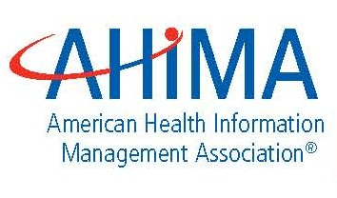
STATEMENT
FOR IMMEDIATE RELEASE: Thursday, July 08, 2010

For more information, please contact: Craig May
AHIMA Director of Public Relations
312-233-1544 (office) 312-404-9763 (cell)
craig.may@ahima.org

AHIMA REACTION TO HHS PROPOSED RULE ON HITECH PRIVACY REGULATIONS

This statement is attributable to: Rita K. Bowen, President
AHIMA Board of Directors

CHICAGO—“The American Health Information Management Association congratulates HHS and its Office for Civil Rights (OCR) on its release of proposed regulations to strengthen the HIPAA privacy and security requirement under last year’s ARRA-HITECH legislation. These rules give healthcare consumers several advantages where electronic health records (EHRs) are concerned. For instance, the new regulations enhance individuals’ access and control over EHRs and, therefore, trust in EHRs and the electronic exchange of health information. This is important as our nation works to improve the health of individuals by having accurate health information available where and when it is needed to treat patients.

“For decades, health information management professionals have been the custodians of individual health information within healthcare organizations and AHIMA looks forward to adding our expertise to the rulemaking process in order to ensure confidentially and privacy are maintained.

“AHIMA has always been centrally involved with educating and training healthcare professionals in the privacy and security of patient health information. Many HIM professionals serve as health information security or privacy officers for health providers, health plans, and other patient care facilities where confidential patient information is obtained, created and maintained.

“These proposed rules represent a striking of the difficult balance between improving appropriate health information access and transfer with the necessary confidentiality and security of that same information or data, and the very important inclusion of patients and their guardians in these activities. AHIMA recognizes this balance and look forward to working with the OCR and the industry to ensure that proper requirements exist that benefit the individual patient both through interoperability and privacy. “

# # #

